CH14 Managing Projects

學習目標:

* 1. 專案管理的目標是什麼？為什麼在開發資訊系統中如此重要？
  2. 可以使用哪些方法來選擇和評估資訊系統專案，並使它們與公司的商業目標保持一致？
  3. 公司如何評估資訊系統的商業價值？
  4. 資訊系統項目中的主要風險因素是什麼，如何對其進行管理？
* Here are some questions to think about: Why was this project successful? Why was it important to break down the project into smaller chunks?

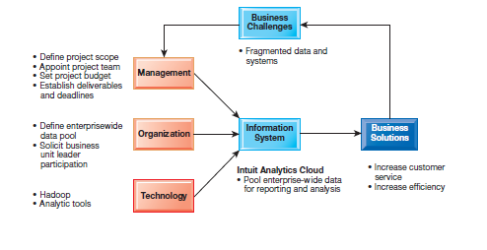

1. What are the objectives of project management, and why is it so essential in developing information systems?
   * Runaway Projects and System Failure

* Runaway projects: 30–40 percent IT projects
* Exceed schedule, budget
* Fail to perform as specified
* Types of system failure
* Fail to capture essential business requirements
* Fail to provide organizational benefits
* Complicated, poorly organized user interface
* Inaccurate or inconsistent data
* Technical performance that is less than expected
* Failure to obtain anticipated benefits

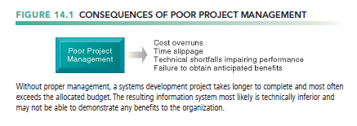

* + Project Management Objectives
* A project is a planned series of related activities for achieving a specific business objective.
* Project management
* Activities include planning work, assessing risk, estimating resources required, organizing the work, assigning tasks, controlling project execution, reporting progress, analyzing results
* five major variables
* scope, time, cost, quality, and risk.

1. What methods can be used for selecting and evaluating information systems projects and aligning them with the firm’s business goals?
   * Management Structure for Information Systems Projects

* Corporate strategic planning group
* Responsible for firm’s strategic plan
* Information systems steering committee
* Reviews and approves plans for systems in all divisions
* Project management group
* Responsible for overseeing specific projects
* Project team
* Responsible for individual systems project

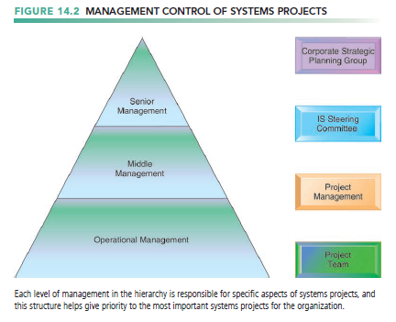

* + Linking Systems Projects to The Business Plan
* Information systems plan
* identify the information systems projects that will deliver the most business value
* Road map indicating direction of systems development, includes
  + Purpose of plan
  + Strategic business plan rationale
  + Current systems/situation
  + New developments
  + Management strategy
  + Implementation plan
  + Budget

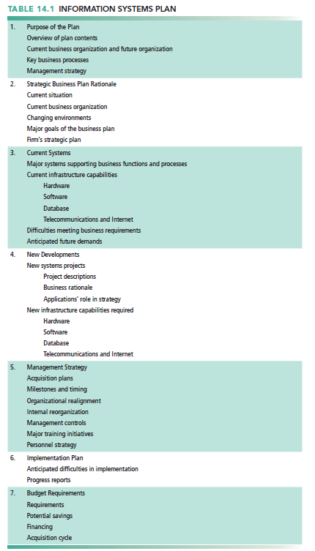

* The plan contains a statement of corporate goals and specifies how information technology will support the attainment of those goals
* The report shows how general goals will be achieved by specific systems projects.
  + Information Requirements and Key Performance Indicators
* To develop an effective information systems plan
* Inventory and document
  + Existing systems and components
  + Decision-making improvements
  + Metrics established for quantifying values
* Clear understanding of long-term and short-term information requirements
* Key performance indicators (KPIs)
* shaped by the industry, the firm, the manager, and the broader environment.
* Strategic analysis identifies small number of KPIs, determined by managers
  + Production costs, labor costs, and so on
  + Portfolio Analysis
* Used to evaluate alternative system projects
* Inventories all of the organization’s information systems projects and assets
* To improve return on portfolio, balance risk and return from systems investments
* Each information systems project carries its own set of risks and benefits.

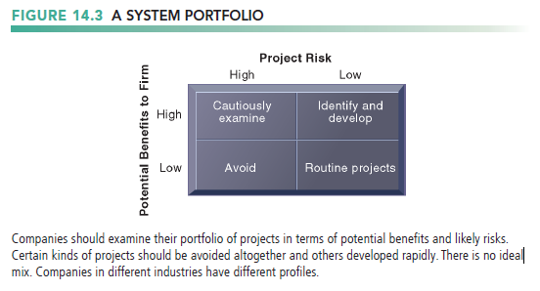

* + Scoring Models
* Used to evaluate alternative system projects, especially when many criteria exist
* Assigns weights to various features of system and calculates weighted totals
* It is appropriate to cycle through the scoring model several times, changing the criteria and weights, to see how sensitive the outcome is to reasonable changes in criteria.

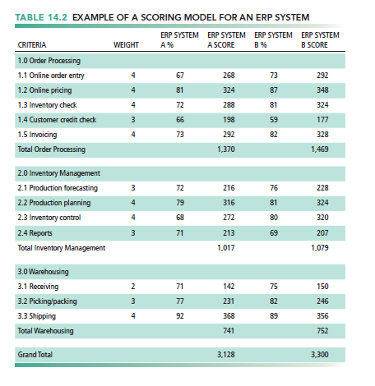

1. How can firms assess the business value of information systems?
   * Information System Costs and Benefits

* Tangible benefits
* Can be quantified and assigned monetary value
* Systems that displace labor and save space
  + Transaction and clerical systems
* Intangible benefits
* Cannot be immediately quantified but may lead to quantifiable gains in the long run
  + For example, more efficient customer service, enhanced decision making
* Systems that influence decision making
  + ESS, DSS, collaborative work systems

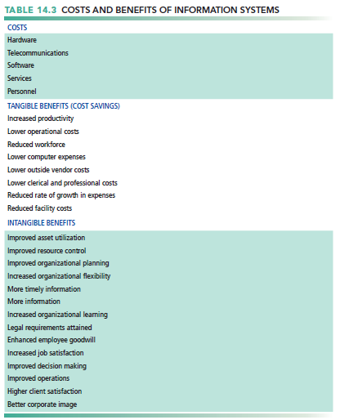

* + Capital Budgeting for Information Systems
* Capital budgeting models
* one of several techniques used to measure the value of investing in long-term capital investment projects.
* Rely on measures the firm’s
  + Cash outflows
  + Cash inflows
* The principal capital budgeting models for evaluating IT projects
  + payback method
  + the accounting rate of return on investment (ROI)
  + net present value
  + the internal rate of return (IRR).
  + Limitations of Financial Models
* Do not take into account social and organizational dimensions that may affect costs and benefits

1. What are the principal risk factors in information systems projects, and how can they be managed?
   * Dimensions of Project Risk

* Level of project risk influenced
* Project size
  + Indicated by cost, time, number of organizational units affected
  + Organizational complexity also an issue
* Project structure
  + Structured, defined requirements run lower risk
* Experience with technology
  + Change Management and the Concept of Implementation
* change management .
* Required for successful system building
* New information systems have powerful behavioral and organizational impact
  + Changes in how information is used often lead to new distributions of authority and power
  + Internal organizational change breeds resistance and opposition
* The Concept of Implementation
* Implementation
  + All organizational activities working toward adoption, management, and routinization of an innovation
* Change agent
  + One role of systems analyst
  + Redefines the configurations, interactions, job activities, and power relationships of organizational groups
  + Catalyst for entire change process
  + responsible for ensuring that all parties involved accept the changes created by a new system.
* The Role of End Users
* With high levels of user involvement
  + System more likely to conform to requirements

Users more likely to accept system

* User–designer communication gap
  + Different backgrounds, interests, and priorities
  + Different loyalties, priorities, vocabularies
  + Different concerns regarding a new system

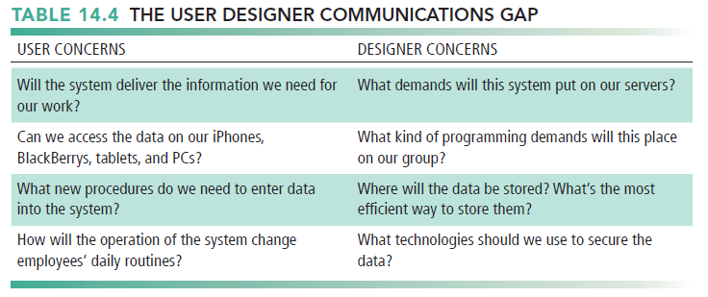

* Management Support and Commitment
* The backing and commitment of management at various levels
  + Effects positive perception by both users and technical staff
  + Ensures sufficient funding and resources
  + Helps enforce required organizational changes
* Change Management Challenges for Business Process Reengineering, Enterprise Applications, and Mergers and Acquisitions
* Very high failure rate among enterprise application and BPR projects (up to 70 percent for BPR)
* Poor implementation and change management practices
  + Employee’s concerns about change
  + Resistance by key managers
  + Changing job functions, career paths, recruitment practices
* Mergers and acquisitions
  + Similarly high failure rate of integration projects
  + Merging of systems of two companies requires : Considerable organizational change, Complex systems projects
  + Controlling Risk Factors
* Preface
* First step in managing project risk involves identifying nature and level of risk of project.
* Each project can then be managed with tools and risk-management approaches geared to level of risk.
* Managing Technical Complexity
* Internal integration tools
  + Project leaders with technical and administrative experience
  + Highly experienced team members
  + Frequent team meetings
  + Essential technical skills or expertise not available internally should be secured from outside the organization.
* Formal Planning and Control Tools
* Used for documenting and monitoring project plans
* Help identify bottlenecks and impact of problems
* Standard control techniques can successfully chart the progress of the project against budgets and target dates, so deviations from the plan can be spotted.
* Gantt charts
  + Visual representation of timing and duration of tasks
  + Human resource requirements of tasks

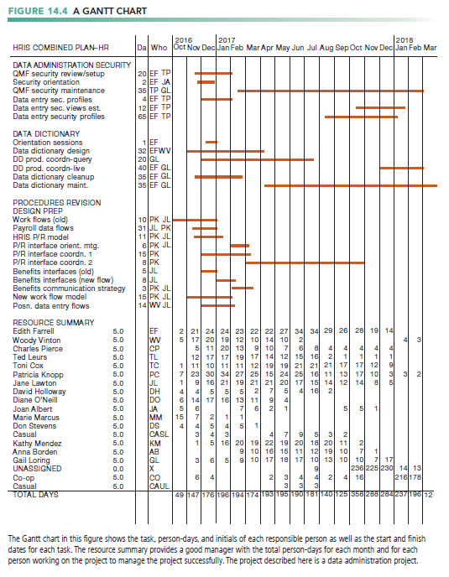

* PERT (program evaluation and review technique) charts
  + Graphically depicts tasks and interrelationships
  + Indicate sequence of tasks necessary

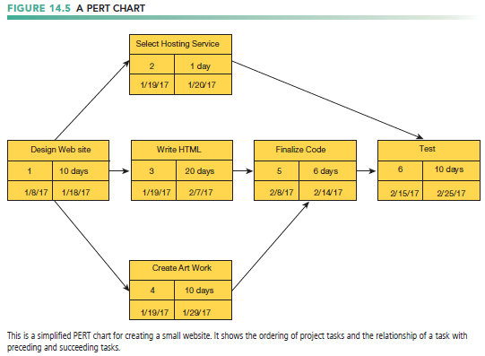

* Increasing User Involvement and Overcoming User Resistance
* External integration tools
  + Link work of implementation team to users at all levels
* User resistance to organizational change
  + Users may believe change is detrimental to own interests
  + Counterimplementation: Deliberate strategy to thwart implementation of a system or innovation in an organization
  + For example, increased error rates, disruptions, turnover, sabotage
* Strategies to overcome user resistance
  + User participation
  + User education and training
  + Management edicts and policies
  + Incentives for cooperation
  + Improvement of end-user interface
  + Resolution of organizational problems prior to introduction of new system
  + Designing for the Organization
* Preface
* Need to address ways in which organization changes with new system
  + Procedural changes
  + Job functions
  + Organizational structure
  + Power relationships
  + Work structure
* Ergonomics: Interaction of people and machines in work environment
  + Design of jobs
  + Health issues
  + End-user interfaces

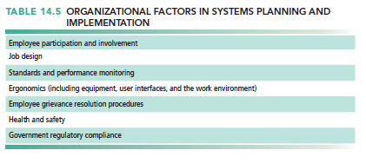

* Organizational impact analysis
  + How system will affect organizational structure, attitudes, decision making, operations
  + thorough and fully documented organizational impact assessments must be given more attention in the development effort.
* Sociotechnical Design
* Addresses human and organizational issues
  + separate sets of technical and social design solutions.
  + explore different workgroup structures, allocation of tasks, and the design of individual jobs.
  + Final design is solution that best meets both technical and social objectives
  + Project Management Software Tools
* Can automate many aspects of project management
* Capabilities for:
* Defining, ordering tasks
* Assigning resources to tasks
* Tracking progress
* Microsoft Project
* Most widely used project management software
* PERT, Gantt charts, critical path analysis
* Increase in SaaS, open-source software
* Project portfolio management software